SDEV325 Homework 1

Mark Kardash

Explanation:

I don’t really have much to say about how I got the program to work. I mostly followed the instructions in the class resources. The difficulties I did have were because I paid slightly less attention to detail than I should have. For instance, I initially did not include the “;” sign at the end of every sentence in C++. When I saw the error that the program displayed, I kept putting them in the wrong places, until I noticed that they had to go in after “endl”. I had also forgotten to close a bracket in the C++ file, and had to use double quotes, instead of single quotes, for the Java file to work. However, it all functioned perfectly in the end. To display the messages, I used five print statements, in accordance with the format of each language.

Testing:

Java:

Python:

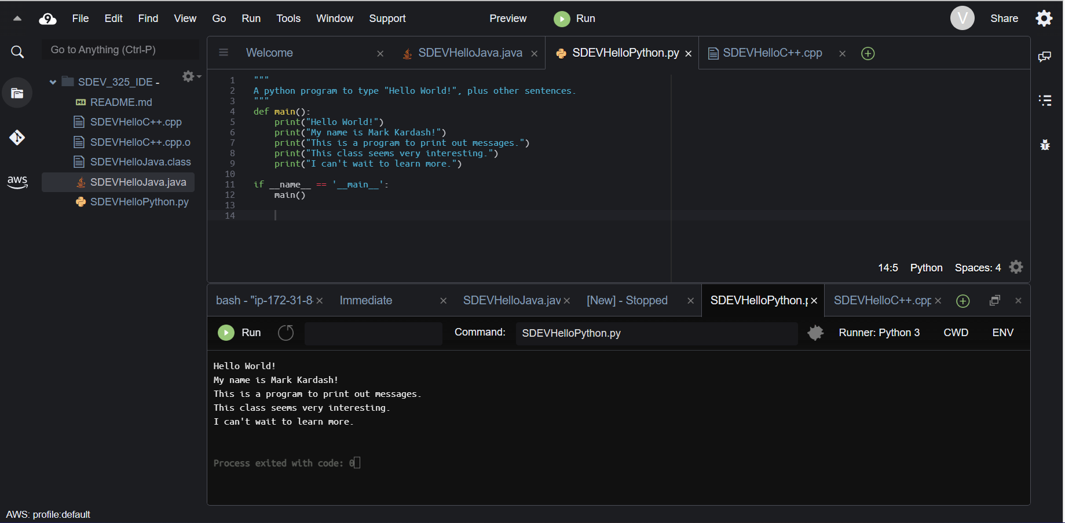

C++

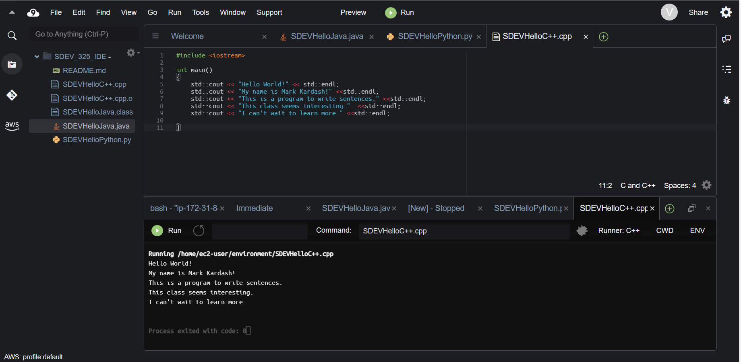

As you can see, everything went perfectly.